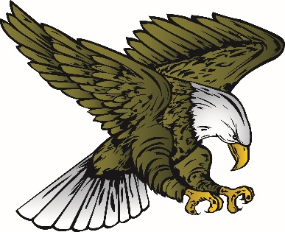
AP English Language and Composition
Mrs. McDermott

Materials Needed
- Blue or black pen (no writing in rainbow colors)
- Pencil
- A folder (you choose the type) – it must be a place where you keep your English work ONLY!
- 2 spiral notebooks (70 pages/college ruled)
- Index cards
- Flash drive
- 1 ream of copy paper - I frequently give close notes (instead of you writing pages of notes, I make copies for the class with a few blanks for you to fill in). If I run out of the copy paper that is allotted to me, you will be taking those notes on your own paper.

Contact Information

E-mail- rebecca.mcdermott@polk-fl.net
Website - http://mcdjediwriting.weebly.com/
**Email is the best way to contact me. I try to answer email the same day I receive it. If you email me at 10:00 pm, you won’t receive a response until the next day. If you email me on a Friday afternoon, odds are you won’t receive a reply until Monday morning.
Register for REMIND.COM by texting your class code to 81010
Per . 3- @mcdgjap3 Per. 5 - @mcdgjap5 Per. 6 - @mcdgjap6 Per. 7 - @mcdgjap7

Reminder
Do not forget your Summer Reading Assignment (The Chosen). It is due Tuesday, September 5 by 2:00 PM.

