Creative Writing – Class Policies/Description
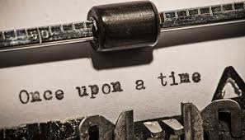
Instructor: Mrs. McDermott
Contact: rebecca.mcdermott@polk-fl.net
Website: http://mcdjediwriting.weebly.com/
Remind: Period 1 – Text @mcdcw1 to 81010
Period 2 – Text @mcdcw2 to 81010

Course Description: Creative Writing is a personal, aesthetic, experiential writing course in which students begin to discover their own artistic voice and progressively inspire their own writing after published works in several genres: poetry, creative non-fiction, short stories, and short plays. The true art of writing includes not only the process of journaling or generating, but also phases of reading, mentoring, experimenting/revising, and editing. All final pieces you will create for this class will reflect the process of writing. Our goal is to become a community of writers who experiment, craft, revise and tinker with our work. Writers see the world as text. The course is conducted as a workshop which provides a forum for discussion of published works as well as their own. Remember: Write with passion and honesty. Make a commitment to your work and take pride in what you write. Do not worry about your creative skills at the beginning of the course; our classroom experiences will be dedicated to improvement no matter what your level today.
We will be sharing ideas and drafts in writing we care about, which requires trust and respect. I will work diligently to create a community of learners and teach you how to support and encourage each other as developing readers and writers. I do not tolerate harassment of any kind in my classroom. Do not push me on this.
Students will be expected to enter final products into professional and/or student contests as well as the school’s literary magazine, to conference with the instructor, participate in writer response groups, research and read contemporary published authors, keep and regularly write in a writer’s notebook, and experiment with and revise writing routinely.
Attendance Policies: Our work together has value and it is in your best interest to be present and participatory each day. If you are absent, please have your absence excused through the attendance office. Whenever possible please notify me of your absences so that I am help you gather the materials you may need to stay up to date with the class.
Attendance is a form of participation. A writing community cannot thrive without each member being present. Students who miss class due to an excused absence may not be able to complete a class assignment since some activities can only be completed within the class setting; however, such an assignment will NOT detract from a student’s grade.
Plagiarism/cheating: Plagiarism and cheating of any kind are unacceptable. Students caught cheating or plagiarizing another’s work will receive a zero on the assignment and their parents will be contacted. Students will NOT be given the opportunity to rewrite the assignment for any credit. Examples of plagiarism include, but are not limited to the following:
- Directly copying passages from or paraphrasing another author’s work into one’s own work without attribution
- Claiming another author’s work is one’s own work
ALL students will participate in a Plagiarism workshop during the first weeks of school.
ALL students will sign and return a Plagiarism Contract. This contract is a grade and MUST include a parent signature.
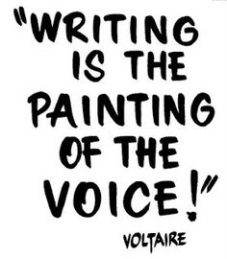
Alert Writing: While one of the fundamental goals of this class is for students to use their unique experiences, aspirations, and inspirations for writing creatively, students should understand that their writing will be read by others. Since all students’ well-being is an utmost priority, any “alert” writing will be investigated (shared with the proper authorities, counselors, parents, etc.) to ensure that the student writer is physically, mentally, and emotionally safe. “Alert” writing is writing that contains depictions of any of the following:
- Gratuitous violence, sex, language, or drug use
- Harm to self or others
- Physical, mental, emotional, or sexual abuse
- Bullying
Grading: You will be graded on your journals (completing entries), written assignments, participation, peer editing, writing projects, and personal progress. The grading scale is based on a points system, and you will be given points for your work. If you hand in all assignments and have made an effort to fulfill the assignments to your best ability, you are guaranteed to get an excellent grade in this class. Doing your best work assures a good grade. Not handing in assignments takes away from your overall grade.
Workshop Participation:
- We discuss what the text/writing achieved or fell short on (not the author/writer)
- The author doesn’t speak until the group is finished critiquing his/her text
- Be respectfully frank and specific (being too nice or too general/abstract is not useful)
- Critique with a text’s potential next evolution in mind (avoid negativity)
- Silence is not a friendly gesture in a creative writing workshop- passivity will be taken as evidence of not having prepared for the discussion.
Projected Units of Study:
- Basics of Writing/Toolbox - common grammatical mistakes, writing skills, usage, plagiarism workshop, Feedback – Editing Workshop,
- Fiction- Elements of Short Fiction (plot, character, setting, conflict, dialogue), Fractured Fairy Tale, Character Development, Conflict, Setting, Children’s Book, Scary Story
- Creative Non-Fiction – Elements of Non-Fiction, Personal Narrative, Letters of gratitude
- Poetry – Poetry Portfolio, Literary Magazine, Submission of work for publication
- Drama – Elements of Drama, Read One Act Plays, Writing and performing an original play
Journal: The purpose of the journal is to give you the opportunity to write every day. It is a place for you to write and create –don’t worry about spelling, grammar, or flow. Just write. Sometimes you will free-write in your journals while other days you will respond to a provided prompt. I just want you to write! Journals will be collected periodically as a means of accountability. I will let you know in advance when they will be collected.
Rules: All Polk County/George Jenkins rules and policies (cell phones, tardiness, absences, etc.) will be followed.

Supplies
- 4 one subject spiral notebooks (one for each quarter – these can usually be purchased for $.25 each during Back to School Sales)
- Black or blue pen
- Color Pen (green, red, or purple) for editing
- Folder (I do not care what kind – it does not have to be a binder; it must be a place for your Creative Writing work only)
- College Ruled Notebook Paper
- Flash Drive
- One box of tissues – you will be glad you donated when cold season arrives

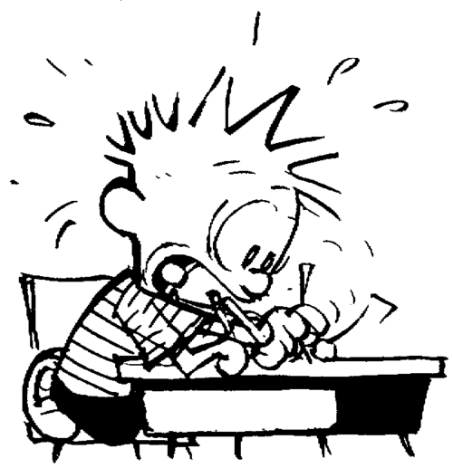
Reminder: This course is an elective, meaning you elected to take it. If you feel that this was a mistake, please change your schedule as soon as possible to accommodate students who would like to have the opportunity to enroll. Keep in mind that this course is what you make of it. I am optimistic that, together, we can make this a wonderful experience that will be beneficial for all of us.

